PHP Exercise 10

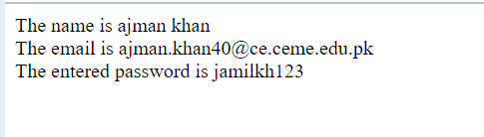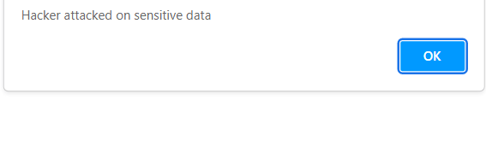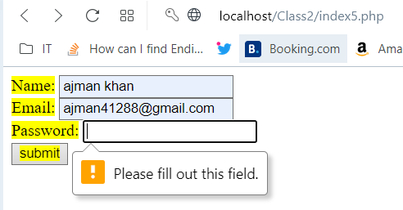

**Form Validation IN PHP With examples :**

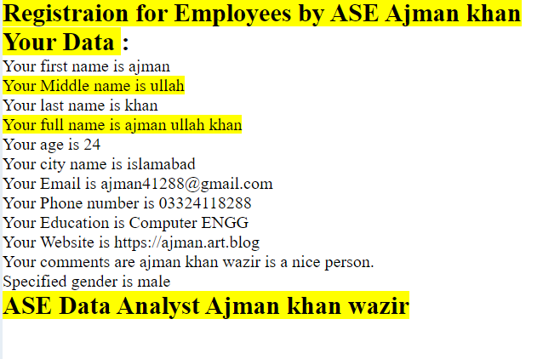

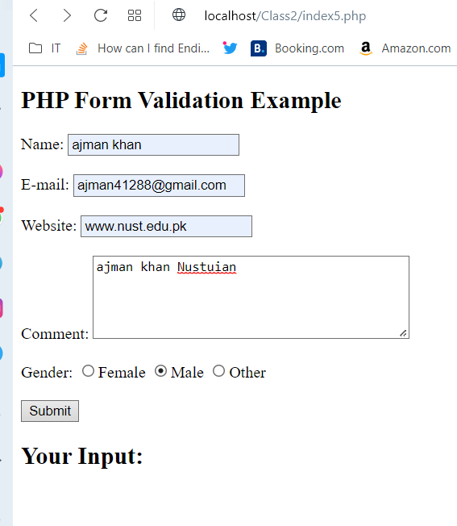

**Index5.php:**

<!DOCTYPE HTML>

<html>

<head>

</head>

<body>

<?php

// define variables and set to empty values

$name = $email = $gender = $comment = $website = "";

if ($_SERVER["REQUEST_METHOD"] == "POST") {

  $name = test_input($_POST["name"]);

  $email = test_input($_POST["email"]);

  $website = test_input($_POST["website"]);

  $comment = test_input($_POST["comment"]);

  $gender = test_input($_POST["gender"]);

}

function test_input($data) {

  $data = trim($data);

  $data = stripslashes($data);

  $data = htmlspecialchars($data);

  return $data;

}

?>

<h2>PHP Form Validation Example</h2>

<form method="post" action="<?php echo htmlspecialchars($_SERVER["PHP_SELF"]);?>">

  Name: <input type="text" name="name">

  <br><br>

  E-mail: <input type="text" name="email">

  <br><br>

  Website: <input type="text" name="website">

  <br><br>

  Comment: <textarea name="comment" rows="5" cols="40"></textarea>

  <br><br>

  Gender:

  <input type="radio" name="gender" value="female">Female

  <input type="radio" name="gender" value="male">Male

  <input type="radio" name="gender" value="other">Other

  <br><br>

  <input type="submit" name="submit" value="Submit">

</form>

<?php

echo "<h2>Your Input:</h2>";

echo $name;

echo "<br>";

echo $email;

echo "<br>";

echo $website;

echo "<br>";

echo $comment;

echo "<br>";

echo $gender;

?>

</body>

</html>

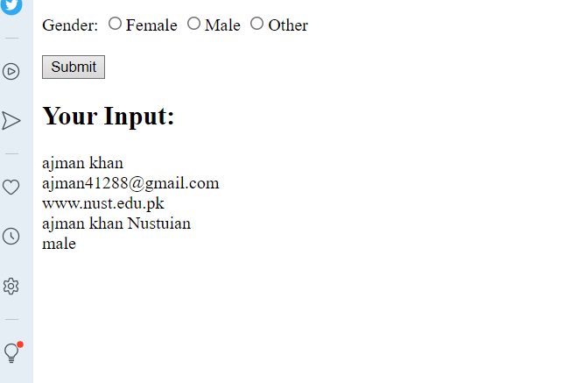

/////////////////////////////

**Form validation all details source codes :**

Index5.php:

<!DOCTYPE HTML>

<html>

<head>

</head>

<body>

<?php

// define variables and set to empty values

$fname = $mname=$lname=$age=$city=$email =$phone=$edu= $gender = $comment = $website = "";

if ($_SERVER["REQUEST_METHOD"] == "POST") {

  $fname = test_input($_POST["fname"]);

  $mname = test_input($_POST["mname"]);

  $lname = test_input($_POST["lname"]);

  $age = test_input($_POST["age"]);

  $city = test_input($_POST["city"]);

  $email = test_input($_POST["email"]);

  $phone = test_input($_POST["phone"]);

  $edu = test_input($_POST["edu"]);

  $website = test_input($_POST["website"]);

  $comment = test_input($_POST["comment"]);

  $gender = test_input($_POST["gender"]);

}

function test_input($data) {

  $data = trim($data);

  $data = stripslashes($data);

  $data = htmlspecialchars($data);

  return $data;

}

?>

<h2><mark>Registraion for Employees by ASE Ajman khan</mark></h2>

<form method="post" action="<?php echo htmlspecialchars($_SERVER["PHP_SELF"]);?>">

<div>

fname:<input type="text" name="fname"   placeholder="Enter first name"  required="required">

<br><br>

mname:<input type="text" name="mname"   placeholder="Enter middle name" required="required" >

<br><br>

lname:<input type="text" name="lname"  placeholder="Enter last name" required="required" >

<br><br>

</div>

<div>

age:<input type="number" name="age"   placeholder="Enter your age" required="required" >

<br><br>

</div>

<div>

city:<input type="text" name="city"  placeholder="Enter your city" required="required">

<br><br>

</div>

<div>

email:<input type="email" name="email"   placeholder="Enter your email" required="required" >

<br><br>

</div>

<div>

phone:<input type="text" name="phone"   placeholder="Enter your phone" required="required">

<br><br>

</div>

<div>

edu:<input type="text" name="edu"   placeholder="Enter your edu" required="required" >

<br><br>

</div>

<div>

  Website: <input type="text" name="website" >

  <br><br>

  </div>

  <div>

  Comment:<br>

  <textarea name="comment" rows="5" cols="40"></textarea>

  <br><br>

  </div>

  <div>

  Gender:

  <input type="radio" name="gender" value="female">Female

  <input type="radio" name="gender" value="male">Male

  <input type="radio" name="gender" value="other">Other

  <br><br>

  </div>

  <input type="submit" name="submit" value="Submit">

</form>

<?php

echo "<h2><mark>Your Data </mark>:</h2>";

echo "Your first name is  $fname";

echo "<br>";

echo "<mark>Your Middle name is  $mname </mark>";

echo "<br>";

echo "Your last  name is  $lname ";

echo "<br>";

echo "<mark >Your full name is  $fname $mname $lname </mark>";

echo "<br>";

echo "Your age is  $age";

echo "<br>";

echo " Your city name is $city ";

echo "<br>";

echo "Your Email is   $email ";

echo "<br>";

echo "Your Phone number  is  $phone ";

echo "<br>";

echo "Your Education  is  $edu ";

echo "<br>";

echo "Your Website is  $website  ";

echo "<br>";

echo "Your comments  are  $comment  ";

echo "<br>";

echo "Specified gender is  $gender ";

?>

</body>

</html>

**Output:**

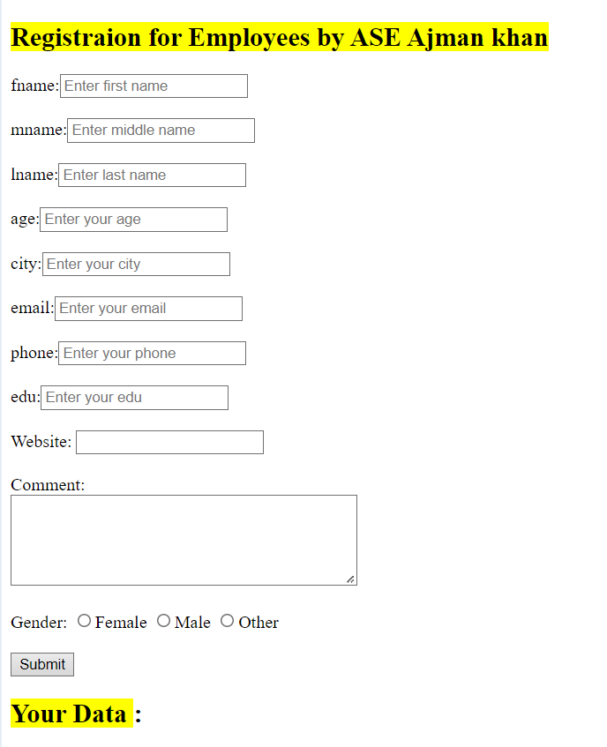

## Registraion for Employees by ASE Ajman khan

窗体顶端

fname:  
  
mname:  
  
lname:

age:

city:

email:

phone:

edu:

Website: 

Comment:  


Gender: Female Male Other



窗体底端

## Your Data :

Your first name is ajman  
Your Middle name is ullah  
Your last name is khan  
Your full name is ajman ullah khan  
Your age is 25  
Your city name is islamabad  
Your Email is ajman.khan40@ce.ceme.edu.pk  
Your Phone number is 03324118288  
Your Education is Computer ENGG  
Your Website is https://ajman.art.blog  
Your comments are ASE data analysts  
Specified gender is male

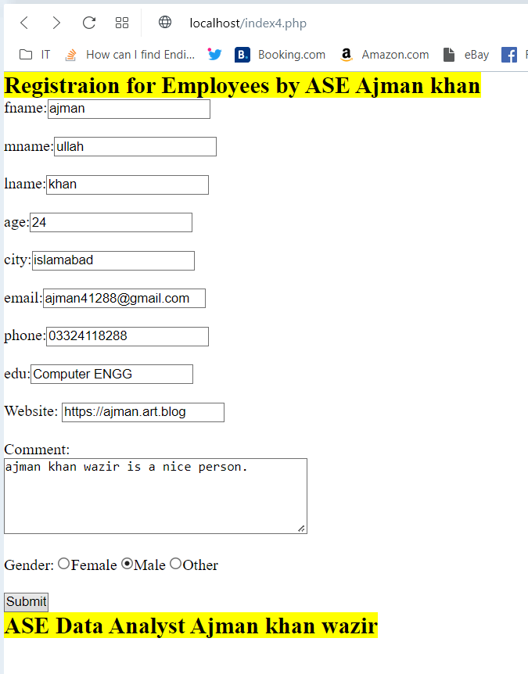

**Form validation and Email,name,websites validation ,errorMessages :**

<!DOCTYPE HTML>

<html>

<head>

</head>

<body>

<?php

// define variables and set to empty values

$fnameerr = $mnameerr=$lnameerr=$ageerr=$cityerr=$emailerr =$phoneerr=$eduerr= $gendererr =

 $commenterr = $websiteerr = "";

// define variables and set to empty values

$fname = $mname=$lname=$age=$city=$email =$phone=$edu= $gender = $comment = $website = "";

if ($_SERVER["REQUEST_METHOD"] == "POST") {

  if(empty($_POST["fname"]))

  {

    $fnameerr="First name is required";

  }

  else{

  $fname = test_input($_POST["fname"]);

// check if name only contains letters and whitespace

if (!preg_match("/^[a-zA-Z-' ]*$/",$fname)) {

  $fnameerr = "Only letters and white space allowed";

}

}

  if(empty($_POST["mname"]))

  {

    $mnameerr="Middle name is required";

  }

  else{

  $mname = test_input($_POST["mname"]);

if(!preg_match("/^[a-zA-Z-']*$/",$mname)){

  $mnameerr="Only letter and white spaces are required";

}

}

  if(empty($_POST["lname"]))

  {

    $lnameerr="last name is required";

  }

  else{

  $lname = test_input($_POST["lname"]);

  if(!preg_match("/^[a-zA-Z-']*$/",$lname)){

    $lnameerr="Only letter and white spaces are required";

  }

}

  if(empty($_POST["age"]))

  {

    $ageerr="Your age is required";

  }

  else{

  $age = test_input($_POST["age"]);}

  if(empty($_POST["city"]))

  {

    $cityerr="city name is required";

  }

  else{

  $city = test_input($_POST["city"]);}

  if(empty($_POST["email"]))

  {

    $emailerr="Email is required";

  }

  else{

  $email = test_input($_POST["email"]);

// check if e-mail address is well-formed

if (!filter_var($email,FILTER_VALIDATE_EMAIL)) {

  $emailerr = "Invalid email format";

}

}

  if(empty($_POST["phone"]))

  {

    $phoneerr="Phone number is required";

  }

  else{

  $phone = test_input($_POST["phone"]);}

  if(empty($_POST["edu"]))

  {

    $eduerr="Eduacation field is required";

  }

  else{

  $edu = test_input($_POST["edu"]);}

  if(empty($_POST["website"]))

  {

    $websiteerr="website is required";

  }

  else{

  $website = test_input($_POST["website"]);

 // check if URL address syntax is valid (this regular expression also allows dashes in the URL)

 if (!preg_match("/\b(?:(?:https?|ftp):\/\/|www\.)[-a-z0-9+&@#\/%?=~_|!:,.;

 ]*[-a-z0-9+&@#\/%=~_|]/i",$website)) {

  $websiteerr = "Invalid URL";

}

}

  if(empty($_POST["comment"]))

  {

    $commenterr="comment are optional ";

  }

  else{

  $comment = test_input($_POST["comment"]);}

  if(empty($_POST["gender"]))

  {

    $gendererr="select gender is  required";

  }

  else{

  $gender = test_input($_POST["gender"]);}

}

function test_input($data) {

  $data = trim($data);

  $data = stripslashes($data);

  $data = htmlspecialchars($data);

  return $data;

}

?>

<h2><mark>Registraion for Employees by ASE Ajman khan</mark></h2>

<form method="post" action="<?php echo htmlspecialchars($_SERVER["PHP_SELF"]);?>">

<div>

fname:<input type="text" name="fname"   placeholder="Enter first name" >

<span class="error">* <?php echo $fnameerr;?></span>

<br><br>

mname:<input type="text" name="mname"   placeholder="Enter middle name"  >

<span class="error">* <?php echo $mnameerr;?></span>

<br><br>

lname:<input type="text" name="lname"  placeholder="Enter last name"  >

<span class="error">* <?php echo $lnameerr;?></span>

<br><br>

</div>

<div>

age:<input type="number" name="age"   placeholder="Enter your age"  >

<span class="error">* <?php echo $ageerr;?></span>

<br><br>

</div>

<div>

city:<input type="text" name="city"  placeholder="Enter your city" >

<span class="error">* <?php echo $cityerr;?></span>

<br><br>

</div>

<div>

email:<input type="email" name="email"   placeholder="Enter your email"  >

<span class="error">* <?php echo $emailerr;?></span>

<br><br>

</div>

<div>

phone:<input type="text" name="phone"   placeholder="Enter your phone" >

<span class="error">* <?php echo $phoneerr;?></span>

<br><br>

</div>

<div>

edu:<input type="text" name="edu"   placeholder="Enter your edu"  >

<span class="error">* <?php echo $eduerr;?></span>

<br><br>

</div>

<div>

  Website: <input type="text" name="website" >

  <mark><span class="error">* <?php echo $websiteerr;?></span></mark>

  <br><br>

  </div>

  <div>

  Comment:<br>

  <textarea name="comment" rows="5" cols="40"></textarea>

  <span class="error">* <?php echo $commenterr;?></span>

  <br><br>

  </div>

  <div>

  Gender:

  <input type="radio" name="gender" value="female" >Female

  <input type="radio" name="gender" value="male">Male

  <input type="radio" name="gender" value="other">Other

  <mark><span class="error">* <?php echo $gendererr;?></span></mark>

  <br><br>

  </div>

  <input type="submit" name="submit" value="Submit">

</form>

<?php

if(isset($_POST['fname'],$_POST['mname'],$_POST['lname'],$_POST['age'],$_POST['city'],

$_POST['email'],$_POST['phone'],$_POST['edu'],$_POST['website'],$_POST['comment'],$_POST['gender'])){

echo "<h2><mark>Your Data </mark>:</h2>";

echo "Your first name is  $fname";

echo "<br>";

echo "<mark>Your Middle name is  $mname </mark>";

echo "<br>";

echo "Your last  name is  $lname ";

echo "<br>";

echo "<mark >Your full name is  $fname $mname $lname </mark>";

echo "<br>";

echo "Your age is  $age";

echo "<br>";

echo " Your city name is $city ";

echo "<br>";

echo "Your Email is   $email ";

echo "<br>";

echo "Your Phone number  is  $phone ";

echo "<br>";

echo "Your Education  is  $edu ";

echo "<br>";

echo "Your Website is  $website  ";

echo "<br>";

echo "Your comments  are  $comment  ";

echo "<br>";

echo "Specified gender is  $gender ";

}

?>

</body>

</html>

Output:

## Registraion for Employees by ASE Ajman khan

窗体顶端

fname: *  
  
mname: * Only letter and white spaces are required  
  
lname: *

age: * Your age is required

city: *

email: *

phone: *

edu: *

Website:  * Invalid URL

Comment:  
 *

Gender: Female Male Other *



窗体底端

## Your Data :

Your first name is ajman  
Your Middle name is 567ah  
Your last name is khan  
Your full name is ajman 567ah khan  
Your age is  
Your city name is islamabad  
Your Email is ajman41288@gmail.com  
Your Phone number is 03324118288  
Your Education is Computer ENGG  
Your Website is ajman  
Your comments are ase data  
Specified gender is male

